City Wide Yard Sale

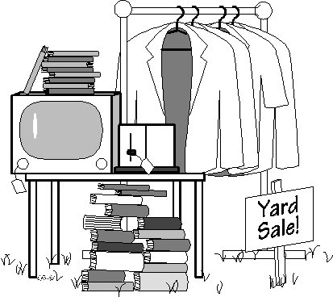

Saturday, May 19th
8am-???

Rain Date: Sunday, May 20th

